# **Stress Ripples**

### On managing your own nervous system

Zoe's avatar

[Zoe](https://substack.com/@zoeffc)

Mar 21, 2025

2

[5](https://femmefuturescooperative.substack.com/p/stress-ripples/comments)

Share

Hi friends,

Here’s one thing they don’t tell you before you go into the working world: Your boss/manager/teammate/collaborator is just a human. Trust me — that was a surprise to me too. At the end of they day, they are just a person with emotions and moods and the ability to be incredibly dysregulated. It’s unavoidable, even with the best people. It will be on you to learn how to keep yourself calm in these situations. Let’s talk about it.



Before I go any further — let’s do the housekeeping.

First, if you are not already a subscriber and you resonate with any of the following descriptors, consider joining the cooperative: (1)Early-career professional; (2) Feminist; (3) Do-Gooder; (4) Former Gifted Kid; (5) Overachiever; or (6) Capitalism-hater.

Subscribed

Second, if you like what I am saying and it makes you think of someone in your family/office/friend group, send it their way.

[Share Femme Futures Cooperative](https://femmefuturescooperative.substack.com/?utm_source=substack&utm_medium=email&utm_content=share&action=share)

Third, I say some personal and vulnerable shit every week. Say some vulnerable shit back. It’s called a community.

[Leave a comment](https://femmefuturescooperative.substack.com/p/stress-ripples/comments)

Okay — back to it.

So right now, I have a pretty incredible boss. She is an awesome teacher, mentor, and friend. People like her are rare — but they exist. I am telling you this not as a way to brag, but as a reality check. Even my incredible boss has days when she is off because she is a human dealing with some massive stressors.

This week, my boss was stressed. For her, this looks like doing everything that she usually does, but faster. I swear, her brain was moving a mile-a-minute. It was hard to keep up and easy to get swept up. Again, remember, my boss is an extremely good person. Even when she is stressed, she stays kind and has a sense of humor. Not all bosses are like that, but all bosses deal with stress. Scratch that — everyone, no matter their position in the hierarchy deals with stress, and we will inevitably react to that stress.

As I was in a meeting with my boss and the rest of my team this week, I realized that her stressed-out, mile-a-minute energy was seeping into my own nervous system. What should I do here? Some options include:

1. Ground myself through my body and breath.
2. Ground myself in the particular tasks that I have on my plate or questions/topics I need to raise in the meeting.
3. Invite my boss and colleagues to take a deep breath.
4. Help to keep the meeting on track through gentle prompting.

I like all of these, but I also have problems with all of them.

**Grounding through my body and breath** is ultimately what I did. It can be done in concert with each of the other options, it is unobtrusive to the meeting, it is invisible, and it is effective. However, it doesn’t address the root of the issue, just my reaction to it.

**Grounding in my work** is good because it keeps me on track for what I need to communicate to and with my team. Additionally, it keeps the stress from spilling onto you in terms of your perception of your workload. The number of tasks that you identified before this interaction are as daunting now as they were 20 minutes ago. The issue here is that this doesn’t address the jump in my heart rate or the extra shot of adrenaline coursing around my body.

**Inviting my boss and team** **to take a deep breath** is something that I genuinely considered. This had a 50/50 chance of being appropriate with this particular group of people, given what I know about them and my relationship with them. This is probably far less appropriate in most other workplaces and situations. Even with it being potentially ok in this particular group, I cringe at the idea of telling my boss to take a deep breath, especially when she’s visibly stressed.

**Helping to keep the meeting on track** would have moved the stress onto me more directly as would have leaned into my need to control volatile situations. Ideally, this would have helped my boss more and even helped my colleagues and ensured that we had an effective meeting. However, given my role in this group, I am not the person best suited to do this and it would have been inappropriate for me to act in this way.

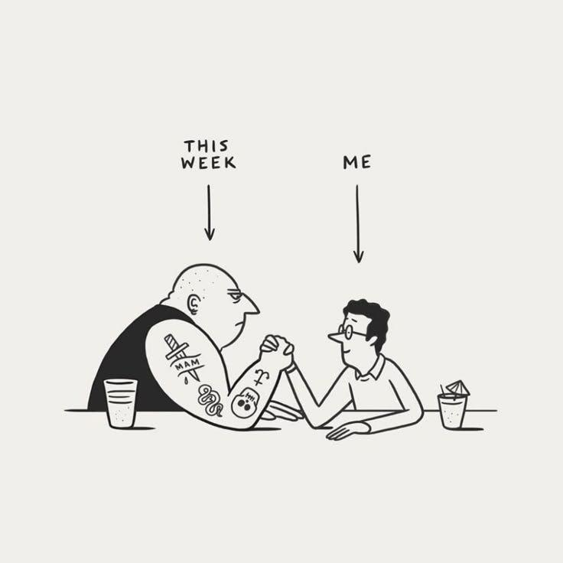

artist unknown

As I took my deep breaths in the meeting, I reflected on how the biggest learning from this situation is that I am in control of my nervous system and no one else’s. As a control freak — I hate this. As a person who is in therapy to deal with her control issues — I love this.

One of my big take-aways in my first few years doing this adult thing is that at the end of the day, you need to know what you feel in your body and how to react to what you are feeling. If you cannot feel the adrenaline or the pulse quickening or it getting harder to breath, you cannot address it. My deep breaths worked in part because I knew exactly what I wanted my body to do.

Still, I think that I can continue to improve how I manage my nervous system in moments like this.

How would you navigate this? Are you someone who gets swept up in other people’s stress? Do you meditate? If so, do you think that helps?

Until next week,

Zoe